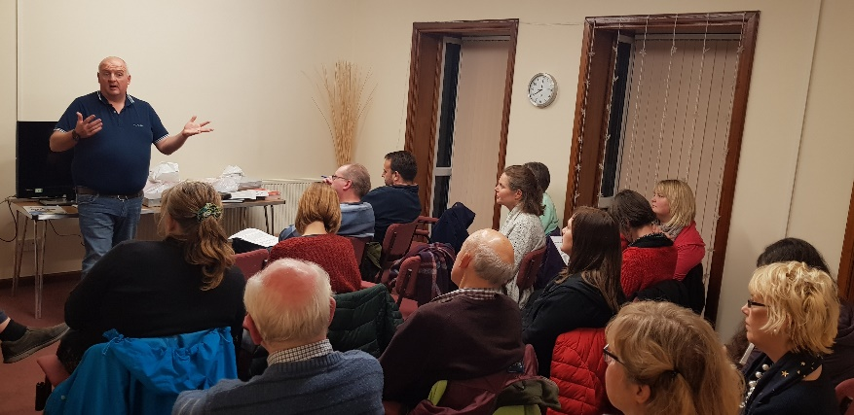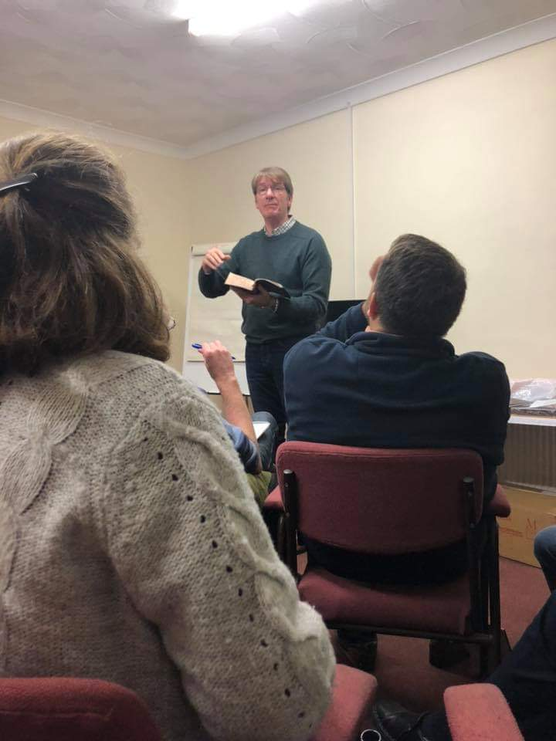

Children and Youth Network Meeting - 3/12/2018
TOP TIPS FOR CHILDREN AND YOUTH WORK

We had 20 people at our first network meeting. The meeting was held in the EMW offices in Bridgend. Each church represented was given a gift of a package of bible studies, course notes and DVDs of Rebekah Manley Pippett encouraging and supporting personal evangelism.

After a warm welcome from Mike, with everyone availing themselves of a drink and some snacks, the evening started with David Norbury introducing the pack and DVDs. He explained that they had been made available by a gift to WLF/EQUIP.

Mike and Mark then spoke about their top tips for youth and childrens’ ministry.,

Mike talked about 5 principals of ministry.

- Prayer – acknowledging that we need God to work, to see people saved. Be prepared to make ourselves the answer to our prayers.
- Dare – to have faith to plan for people to get saved, the faith to dare something! Rightly we should expect seeds to bear fruit!!! A farmer expects the seeds to produce a crop - so should we.
- Care – asking God for a heart for the lost - the youngsters really matter - do they really matter to you?
- Be there – the essential importance of relationships -build bridges - or zip wires - so that eventually the juggernaut of the gospel can be driven over it. Invest in relationships - in people.
- Share – we need to also speak the truth, we must live and speak - as natural as breathing in and out!!

Mark made four striking statements - illustrated by scripture and experience
- Travel Light
From the story of Laban in Genesis 31 v 33 we can pick up and try to carry unnecessary loads. Things we should not pick up. For example hurts - they can weigh you down - we need an on-going process of forgiveness in our lives.
2. Most people quit just before the miracle happens
Bible characters hit obstacles. Moses - the Red Sea; David - Goliath; Paul - faced danger and death; Ziclag - threatened with stoning to death. They had the ability to trust themselves to the Lord - not to quit - to trust - however impossible the situation appeared to be.
3. We need a warrior spirit
Jonathan and his armour bearer where there were many more of the enemy - “Perhaps God …” - and then he attacked! The young men sent into the fiery furnace …”our God is able …but even if he does not we will not bow” - nothing was or is guaranteed. But this is attractive courage. After a fascinating illustration linked to Star Trek and a no win scenario - we were encouraged to reprogram ourselves to know that the game is not up - and perhaps God will turn things around in our day.
4. The purpose of the our work is the transformation of all human life under God
Counting numbers if not what we are about. We are to make disciples of all nations. At one point the disciples returned to Jesus with great joy - even demons are subject to them. Hell itself is under God and our control. Don’t count heads - aim for the transformation of all human life under God!

Open discussion and questions

We had a good time of sharing and encouraging each other. The purpose of this network was to encourage and support each other where that is possible.
Patrick told is that there were encouragements from answered prayer in Llanelli relating to recent developments prayed for for a long time.

One of the things that really stood out for Mike was when one lady from Newport offering to help another lady from Newport to do a kids club they were from different churches.

A light party in Llanelli was a significant indicator of what is possible and could open the door for future gospel work.

Jonathan shared some prayer requests - highlighting the many things which were happening in churches and ministries related to his work in Cardiff. Some Christmas activities which he would want us to pray for are:
Dec 19 - Grace Church outreach in Grangetown with Christmas questionnaires
Dec 20 - Street outreach in Cardiff with Open Air Mission team
Dec 21 – Street outreach in Pontypridd in partnership with St Catherine’s Church & then in evening the Tamil (Indian) Fellowship Christmas Celebration where I hope to take Vijay, the Indian we met during door-to-door in Grangetown.
Dec 23 – We plan to go to Bristol to join a family member at the church where he is now serving to begin our family Christmas time together.

Finally I leave you with a quote from Watchman Nee about prayer that someone shared with us this morning. ‘Our prayers lay the track down which God’s power can come. Like a mighty locomotive, his power is irresistible, but it cannot reach us without rails.’
Prayer makes a difference. Thanks for praying for us.
Jonathan & Amy Harris

The next network meeting of Children and Youth Network, will be in Waterton Cross Business Park, South Road, Bridgend CF31 3UL, (EMW Head Office) for Monday, March 4th.The meeting will be from 7-8:30pm

